Module 5.
Automated Acceptance Testing

Technical requirements

To complete this module, you'll need the following software:

• Jenkins
• Docker
• The Java Development Kit (JDK) 8+

Introducing acceptance testing
Acceptance testing is a step performed to determine whether the business requirements or contracts are met. It involves black-box testing against a complete system from a user perspective, and a positive result means acceptance of the software delivery. Sometimes also called user acceptance testing (UAT) or end-user testing, it is a phase of the development process where software meets a real-world audience.

Many projects rely on manual steps performed by quality assurers (QAs) or users to verify the functional and non-functional requirements (FRs and NFRs), but still, it's way more reasonable to run them as programmed repeatable operations.

Automated acceptance tests, however, can be considered difficult due to their specifics, as outlined here:

• User-facing: They need to be written together with a user, which requires an understanding between two worlds—technical and non-technical.

• Dependencies integration: The tested application should be run together with its dependencies in order to check that the system as a whole works properly.

• Staging environment: The staging (testing) environment needs to be identical to the production one so as to ensure the same functional and non-functional behavior.

• Application identity: Applications should be built only once, and the same binary should be transferred to production. This eliminates the risk of different building environments.

• Relevance and consequences: If the acceptance test passes, it should be clear that the application is ready for release from the user's perspective.

Installing and using the Docker Registry
The Docker Registry is a store for Docker images. To be precise, it is a stateless server application that allows the images to be published (pushed) and later retrieved (pulled).

We already saw an example of the Registry when running the official Docker images, such as hello-world . We pulled the images from Docker Hub, which is an official cloud-based Docker Registry. Having a separate server
to store, load, and search software packages is a more general concept called the software repository or, in even more general terms, the artifact repository.

The artifact repository
While the source control management stores the source code, the artifact repository is dedicated to storing software binary artifacts, such as compiled libraries or components, later used to build a complete application. Why do we need to store binaries on a separate server using a separate tool? Here's why:

• File size: Artifact files can be large, so the systems need to be optimized for their download and upload.

• Versions: Each uploaded artifact needs to have a version that makes it easy to browse and use. Not all versions, however, have to be stored forever; for example, if there was a bug detected, we may not be interested in the related artifact and remove it.

• Revision mapping: Each artifact should point to exactly one revision of the source control and, what's more, the binary creation process should be repeatable.

• Packages: Artifacts are stored in a compiled and compressed form so that these time-consuming steps don't need to be repeated.

• Access control: Users can be restricted differently in terms of access to the source code and artifact binary.

• Clients: Users of the artifact repository can be developers outside the team or organization who want to use the library via its public application programming interface (API).

• Use cases: Artifact binaries are used to guarantee that exactly the same build version is deployed to every environment to ease the rollback procedure in case of failure.

Information
The most popular artifact repositories are JFrog Artifactory and Sonatype Nexus.

The artifact repository plays a special role in the CD process because it guarantees that the same binary is used throughout all pipeline steps.

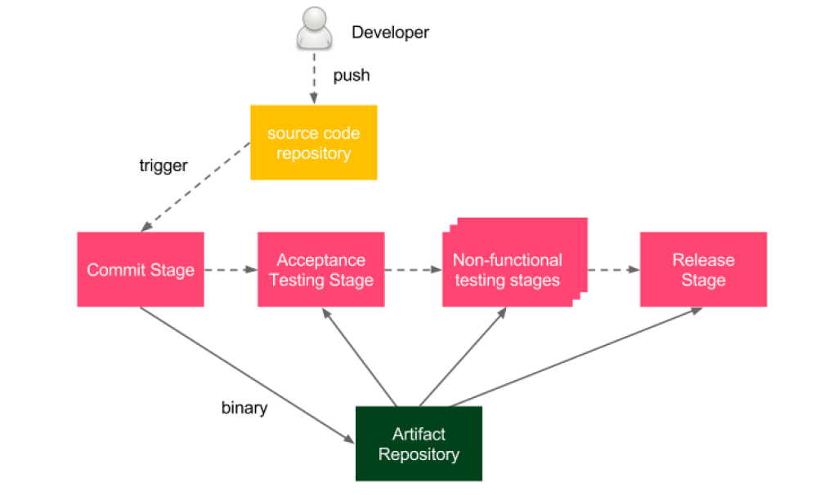

Figure 1 – Artifact repository in the CD process

The developer pushes a change to the source code repository, which triggers the pipeline build. As the last step of the commit stage, a binary is created and stored in the artifact repository. Afterward, during all other stages of the delivery process, the same binary is (pulled and) used.

We work with Docker, so we will store Docker images as artifacts, and the tool to store Docker images is called the Docker Registry.

Installing a Docker Registry
First, we need to install a Docker Registry. There are a number of options available, but all of them fall into two categories: a cloud-based Docker Registry and a self-hosted Docker Registry.

Self-hosted Docker Registry
Cloud solutions may not always be acceptable. They are not free for enterprises and, what's even more important, a lot of companies have policies not to store their software outside their own network. In this case, the only option is to install a self-hosted Docker Registry.

Installing the Docker Registry application
The Docker Registry is available as a Docker image.

Using the Docker Registry

When our registry is configured, we can show how to work with it in three stages, as follows:

• Building an image
• Pushing the image into the registry
• Pulling the image from the registry

Building an image

Pushing the image into the registry
In order to push the created image, we need to tag it according to the naming convention, like this:

<registry_address>/<image_name>:<tag>

The registry_address value can be either of the following:

• A username in the case of Docker Hub
• A domain name or Internet Protocol (IP) address with a port for a private registry (for example, localhost:5000 )

Information
In most cases, <tag> is in the form of the image/application version.

Pulling the image from the registry

Acceptance tests in the Jenkins pipeline
Let's look at the following diagram, which presents the process we will use:

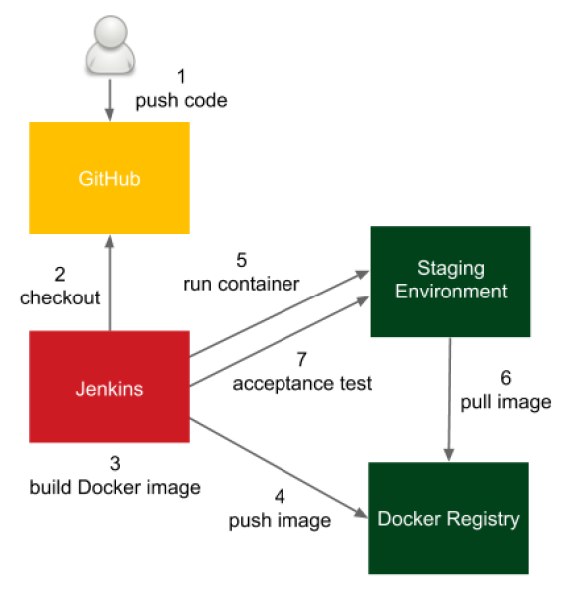

Figure 2 – Acceptance tests in the Jenkins pipeline

The process goes like this:

1. The developer pushes a code change to GitHub.
2. Jenkins detects the change, triggers the build, and checks out the current code.
3. Jenkins executes the commit phase and builds the Docker image.
4. Jenkins pushes the image to the Docker Registry.
5. Jenkins runs the Docker container in the staging environment.
6. The Docker host on the staging environment needs to pull the image from the Docker Registry.
7. Jenkins runs the acceptance test suite against the application running in the staging environment.

Let's continue the pipeline, Continuous Integration Pipeline, and add three more stages, as follows:

• Docker build
• Docker push
• Acceptance test

Keep in mind that you need to have the Docker tool installed on the Jenkins executor (agent or master, in the case of agentless configuration) so that it can build Docker images.

The acceptance testing stage
To perform acceptance testing, we first need to deploy the application to the staging environment and then run the acceptance test suite against it.

Adding an acceptance test to the pipeline
Acceptance testing usually requires running a dedicated black-box test suite that checks the behavior of the system.

Writing acceptance tests
We can use the curl command to perform a suite of acceptance tests. That is, obviously, a considerable simplification. Technically speaking, if we write a REpresentational State Transfer (REST) web service, we could write all black-box tests as a big script with a number of curl calls. However, this solution would be very difficult to read, understand, and maintain. What's more, the script would be completely incomprehensible to non-technical, business-related users. How do we address this issue and create tests with a good structure that are readable by users and meet their fundamental goal: automatically checking that the system is as expected?

Writing user-facing tests
Acceptance tests are written with users and should be comprehensible to users.

In real life, most software is written to deliver a specific business value, and that business value is defined by non-developers. Therefore, we need a common language to collaborate.
On one side, there is the business, which understands what is needed but not how to do it; on the other side, the development team knows how but doesn't know what. Luckily, there are a number of frameworks that helps to connect these two worlds, such as Cucumber, FitNesse, JBehave, and Capybara.

The acceptance criteria are written by users (or a product owner as their representative), with the help of developers.

Developers write the testing implementation, called fixtures or step definitions, that integrates the human-friendly domain-specific language (DSL) specification with the programming language.
As a result, we have an automated test that can be easily integrated into the CD pipeline.

Using the acceptance testing framework
Cucumber framework can create an acceptance test.

1. Creating acceptance criteria
2. Creating step definitions
3. Running an automated acceptance test.

